Project IDEA NOTE
Dear student
The idea presented is one such real time application in the sustainability and shall not be limited to.

Tentative Title
A GPU-Accelerated Self-Learning Digital Twin System for Real-Time Energy Optimization Using Synthetic Climate Simulation
Field of Invention
The invention relates to GPU computing, artificial intelligence, digital twins, and energy optimization, and more particularly to a purely software-based system that uses GPU-accelerated synthetic simulations to optimize energy consumption without physical sensors or hardware deployment.
Background of the Invention
Current smart energy and climate optimization systems depend heavily on:
- Physical IoT sensors
- Real-time data acquisition
- Costly infrastructure and maintenance
These limitations make large-scale deployment expensive and slow. There is no existing system that can:
- Learn climate–energy behavior without sensors
- Continuously optimize energy usage using GPU-based parallel simulations
- Operate purely on a computer with a GPU
Problem Statement
Existing AI-based energy optimization methods:
- Require real-world data collection
- Are slow to adapt to new buildings or layouts
- Cannot scale rapidly without installing hardware
There is a need for a software-only intelligent system that:
- Learns building energy behavior virtually
- Uses GPU parallelism for fast optimization
- Can be deployed instantly on any GPU-enabled computer

Summary of the Invention
The proposed invention introduces a GPU-accelerated digital twin engine that creates thousands of parallel synthetic climate and energy simulations of a building environment using a single computer equipped with a GPU.
The system:
- Generates virtual environmental states
- Trains AI models using GPU parallelism
- Continuously updates an optimal energy control policy
- Requires no physical sensors or IoT devices
Core Novelty (Key Patent Claim Idea)
A method wherein a graphics processing unit (GPU) executes multiple parallel synthetic climate simulations to train and optimize an artificial intelligence model for energy management, without relying on real-time physical sensor data.
This is the inventive step.

System Architecture (Conceptual)
- Input Module
  - Building geometry
  - Material properties
  - Historical climate profiles (static datasets)
- GPU Simulation Engine
  - Thousands of climate scenarios simulated in parallel
  - Heat transfer, occupancy patterns, energy loads
- AI Optimization Module
  - Reinforcement learning or neural networks
  - Learns optimal energy strategies from simulations
- Decision Output Module
  - Energy control recommendations
  - Scenario-based optimization results
- Self-Learning Loop
  - Continuous refinement using GPU retraining
All modules run entirely on a GPU-enabled computer
Why GPU is Essential (Patent Strength)
- CPU: sequential simulations → slow
- GPU: massively parallel simulations → fast convergence
- Enables real-time digital twin learning
This cannot be reasonably achieved on a CPU alone, strengthening patent novelty.
Note: The below is an AI Generated Image for our reference
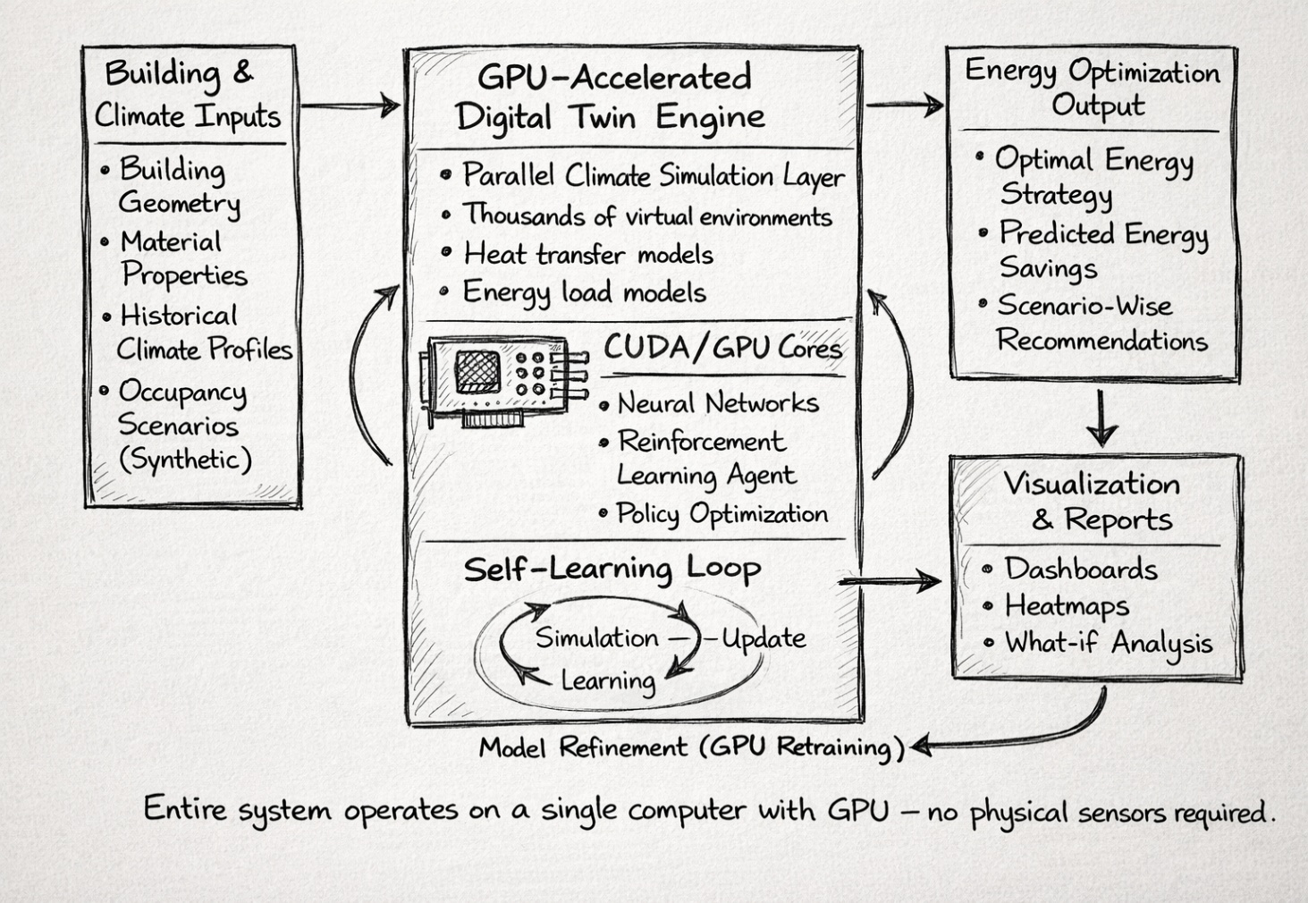
Explanation of the Hand-Drawn Architecture Diagram
The architecture illustrates a GPU-Accelerated Digital Twin system designed for energy optimization using purely software-based intelligence. On the left, the system begins with Building and Climate Inputs, which include building geometry, material properties, historical climate profiles, and synthetically generated occupancy scenarios. These inputs do not come from physical sensors but are predefined or simulated datasets that describe the building and its environment.
At the center, the core of the system is the GPU-Accelerated Digital Twin Engine, which is the most critical and innovative component. This engine uses the massive parallelism of the GPU to run thousands of virtual climate and energy simulations simultaneously. Inside this engine, heat transfer models and energy load models simulate how buildings behave under different conditions. A GPU-based AI module, implemented using CUDA-enabled neural networks and reinforcement learning agents, continuously learns optimal energy strategies. The self-learning loop shown at the bottom highlights how simulation, learning, and model updating occur iteratively, allowing the system to improve without external intervention.
On the right, the system generates Energy Optimization Outputs, such as optimal energy strategies, predicted energy savings, and scenario-wise recommendations. These results are further processed in the Visualization and Reporting module, producing dashboards, heatmaps, and “what-if” analyses that help users understand and apply the insights. A feedback arrow connects the visualization stage back to the GPU engine, indicating continuous model refinement through GPU retraining.
The key significance of this architecture is that the entire system operates on a single computer equipped with a GPU, without requiring any physical sensors or IoT hardware. This makes the invention highly scalable, cost-effective, and suitable for rapid deployment in energy planning, climate modeling, and sustainability applications.
If you want, I can next:
- Convert this explanation into patent-ready “Detailed Description of Drawings” language, or
- Help you write claim-mapping text referencing this figure (e.g., Fig. 1 illustrates…), or
- Adapt this explanation into a student lecture narrative.
Advantages of the Invention
No hardware or sensors required
Extremely scalable (cloud or local GPU)
Low deployment cost
Rapid adaptation to new environments
Energy-efficient computation per simulation
Suitable for climate, energy, and smart city planning

Potential Applications
- Virtual energy audits
- Smart building planning
- Climate impact forecasting
- Energy policy simulation
- Smart city digital twins
- Academic and industrial AI modeling

Example Use Case (Easy to Explain)
A building manager enters building dimensions into the system.
The GPU instantly simulates 10,000 climate scenarios.
The AI model learns the most energy-efficient strategy — without installing a single sensor.

Patent Claims (High-Level Examples)
- A computer-implemented method for energy optimization using GPU-parallel synthetic simulations.
- The method wherein AI models are trained exclusively on simulated climate data.
- The method wherein reinforcement learning agents are trained using GPU-accelerated scenario generation.
- A system that continuously refines energy strategies without real-time sensor feedback.

Why This Is a Strong Patent Idea
- ✔ Pure software (fast filing, low cost)
- ✔ Uses GPU as a core inventive element
- ✔ Independent of hardware trends
- ✔ Aligned with sustainability & AI
- ✔ Scalable globally

What the Digital Twin “Does” Step by Step
Creates a virtual building
Runs thousands of climate scenarios
Predicts energy consumption
Trains AI using GPU
Learns best energy strategies
Updates itself continuously

One-Line Patent Pitch
“A GPU-based intelligent digital twin that learns how to save energy before energy is ever consumed.”

